**PROJECT REPORT**

**On**

**FLOOD DETECTION AND MANAGEMENT SYSTEM**

***Submitted by***

**LIYA T MATHEW**

***in partial fulfillment for the award of the degree***

***Of***

**BACHELOR OF TECHNOLOGY**

**in**

**ELECTRONICS AND COMMUNICATION ENGINEERING** 

**DIVISION OF ELECTRONICS ENGINEERING**

**SCHOOL OF ENGINEERING**

**COCHIN UNIVERSITY OF SCIENCE AND TECHNOLOGY**

**KOCHI-682022**

**APRIL 2023**

**SCHOOL OF ENGINEERING**

**COCHIN UNIVERSITY OF SCIENCE AND TECHNOLOGY**

**KOCHI-682022**



**CERTIFICATE**

*Certified that the report entitled “****FLOOD DETECTION AND MANAGEMENT SYSTEM*** *” is a bonafide work of* ***LIYA T MATHEW*** *towards the partial fulfillment for the award of the degree of B-Tech in Electronics and Communication of Cochin University of Science and Technology, Kochi-682022.*

**Staff-in-Charge Head of Division**

**Mr. Unni A M Dr. Anju Pradeep**

**ACKNOWLEDGEMENT**

We express our overwhelming indebtedness to God Almighty for the successful completion of our project. First and foremost, we express our gratitude to Dr. Anju Pradeep, Head of the Division of Electronics and Communication Engineering. We would like to thank our project guide, Mr Unni A M, for guiding us in our project and providing us with adequate facilities in order to complete the task we had undertaken. Our sincere gratitude is expressed and extended to our lab staff and other faculty members of the Electronics and Communication Division for their assistance and unwavering support. We proudly thank all our friends who helped us in various stages of this endeavor.

**ABSTRACT**

Floods have created a devastating impact on communities worldwide, causing extensive damage to homes, infrastructure, and critical resources such as clean water and food supplies. The lack of early warning systems and flood prediction capabilities has been a major contributing factor to these tragic outcomes, resulting in a significant loss of human life and economic costs.To address this critical issue, an innovative IoT framework has been proposed to monitor water bodies using IoT devices. These devices will transmit frequent updates on temperature,humidity ,rainfall and water levels which will be used to carry out a range of essential functions such as forecasting flood risks and implementing timely emergency responses.As soon as abnormal water levels are detected, an alert system will be activated, and relevant information will be transmitted to local residents to help them make informed decisions and take prompt action. By providing real-time information and guidance, this framework has the potential to save countless lives and reduce the devastating impact of floods on communities around the world.

**CONTENTS**

**1**. **INTRODUCTION …………………………………………………………………… 1**

**2. RESEARCH ON EXISTING SYSTEMS …………………………………………………. 2**

**3. SOFTWARE …………………………………………………………………. 3**

**3.1**  Proteus ……………………………………………………………………… 3

**3.2** Tinkercad ……………………………………………………………………. 3

**3.3** Arduino IDE …………………………………………………………………. 3

**3.4** ThingSpeak™ ………………………………………………………………. 4

**3.5**  Google colab ………………………………………………………………………. 4

**4**. **HARDWARE COMPONENTS ……………………………………………………. 5**

**4.1** Arduino uno …………………………………………………………………… 5

**4.2** NodeMCU ……………………………………………………………………. 6

**4.3** DHT11 sensor ………………………………………………………………... 7

**4.4** ultrasonic sensor …………………………………………………………….. 7

**4.5** Water level sensor …………………………………………………………… 8

**4.6** GSM Module ………………………………………………………………… 9

**5.** **PROJECT IMPLEMENTATION……………………………………………………. 10**

**5.1** Design …………………………………………………………………………… 10

**5.2** Circuit ……………………………………………………………………………………. 11

**5.3**  Working ………………………………………………………………………….. 12

**5.4** Communication Protocol-ESP Now ………………………………………….. 13

**6.** **OUTPUT ……………………………………………………………………………. 15**

**6.1** GSM Module Alert ……………………………………………………………… 15

**6.2** Thingspeak Data Visualization ……………………………………………….. 16

**6.3** Web page………………………………………………………………………… 17

**6.4** Machine Learning……………………………………………………………….. 18

**7. FUTURE SCOPE ……………………………………………………………... 19**

**8. CONCLUSION ……………………………………………………………….. 20**

**9. REFERENCES …………………………………………………………………….. 21**

**List of Figures**

**1.1 : Flood ………………………………………………………………………………… 1**

**2.1 : Water Level Measuring System in Dams ………………………………………. 2**

**4.1 : Arduino uno ………………………………………………………………….. 5**

**4.2 : NodeMCU …………………………………………………………………………… 6**

**4.3 : DHT11 sensor ……………………………………………………………………… 7**

**4.4 : Ultrasonic sensor …………………………………………………………………. 8**

**4.5 : Water level sensor …………………………………………………………………. 8**

**4.6 : GSM Module ………………………………………………………………………… 9**

**5.1 : Device placing Under the bridge ………………………………………………… 10**

**5.2 : Circuit ………………………………………………………………………………… 11**

**5.3 : Block Diagram of Working ……………………………………………………….. 12**

**5.4 : ESP32 Sender to Receiver Board ………………………………………………. 13**

**5.5 : MAC Address ……………………………………………………………………… 14**

**6.1 : Alert Through GSM ………………………………………………………………… 15**

**6.2 : Thingspeak Data Visualization ………………………………………………….. 16**

**6.3 : Web page output …………………………………………………………………… 17**

**6.4 : Final Prediction Accuracy ………………………………………………………… 18**

## **1. INTRODUCTION**

Floods are one of the most devastating natural disasters, causing significant loss of life and damage to property and infrastructure worldwide. The lack of accurate and timely flood prediction and warning systems is a major contributing factor to these outcomes. In recent years, the emergence of the Internet of Things (IoT) has provided new opportunities for developing innovative flood detection and alert systems.Such systems leverage IoT sensors and wireless communication technologies to collect real-time data on water levels and send timely alerts to stakeholders, including emergency responders and local communities. This project presents a flood detection and alert system based on an IoT framework that uses various sensors to monitor water levels in real-time. The proposed system is designed to be reliable, scalable, and cost-effective. The communication protocol used in the system is ESP NOW, which is a high-speed and low-power communication protocol that allows for efficient transmission of data between IoT devices.It utilizes machine learning algorithms to analyze sensor data and predict potential flood risks, enabling timely and effective flood response strategies.The system's web interface provides accessible and comprehensive information on water levels, weather conditions and whether the current conditions are safe or not based on the machine learning prediction mechanism.The proposed system is expected to reduce the impact of floods on communities, ultimately saving lives and reducing property damage[1]



**Figure 1.1: Flood**

**2. RESEARCH ON EXISTING SYSTEMS**

The report, 'Preparedness and Response to Floods in Kerala', has highlighted the need for a more efficient and effective system for monitoring and responding to floods in the region. Currently, only six rain gauges are available for estimating rainfall in the Periyar basin, where 32 are actually required. This shortage of rain gauges has led to an inefficient system that is unable to provide accurate information during times of emergency. Moreover, there is no existing system for proper alerting and evacuation, which can further exacerbate the situation in the event of a flood.To address these issues, our system incorporates sensors that are capable of measuring the water level in real-time and transmitting this data to an IOT platform for analysis and visualization. By using this system, we can ensure that accurate and timely data is available to the authorities, which can help them take necessary measures to mitigate the impact of floods. The data collected by the sensors would then be made available on a website that also maintains a proper alert system.

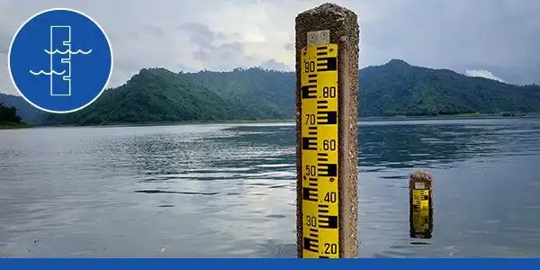

**Figure 2.1 : Water Level Measuring System in Dams**

**3. SOFTWARE**

**3.1 PROTEUS**

Proteus is a software tool used for the simulation of electronic circuits. It is a virtual environment where you can design, test and debug your electronic projects before actually building them. Proteus includes a suite of tools that allow for the design and simulation of circuits, the creation of custom PCB layouts, and the testing of microcontroller firmware in a virtual environment. The software also has a large library of electronic components that can be used in your designs, making it a useful tool for both hobbyists and professionals in the electronics industry. Proteus is widely used for educational purposes and is also used by engineers and designers for testing their circuits before physically implementing them.

**3.2 Tinkercad**

Tinkercad is an online collection of software tools from Autodesk that enable complete beginners to create [3D models](https://www.3dnatives.com/en/10-free-modeling-software-210720204/). This [CAD software](https://www.3dnatives.com/en/top10-cad-software-180320194/) is based on constructive solid geometry (CSG), which allows users to create complex models by combining simpler objects together. As a result, this 3D modeling software is user-friendly and currently enjoyed by many, particularly teachers, kids, hobbyists, and designers. Best of all, it’s free and only requires an internet connection. The software allows users to create models that are compatible with 3D printing, a great option for beginners to the technology.

**3.3****Arduino IDE**

Arduino IDE is an integrated development environment used to write, compile, and upload code to Arduino boards. It is a software platform that makes it easy for beginners and professionals to create projects using Arduino boards. The IDE comes with a simple and user-friendly interface that enables users to write code in C/C++ programming languages. The code is then compiled into a binary file that can be uploaded onto an Arduino board via a USB connection. The IDE also comes with a serial monitor feature that allows users to debug their code and see the output of their programs in real-time.The IDE is available for free download on the Arduino website and is compatible with Windows, macOS, and Linux operating systems.

**3.4 ThingSpeak™**

ThingSpeak is an Internet of Things (IoT) platform that allows users to collect, analyze, and visualize data from sensors or devices. It is a cloud-based platform that provides a way to store and retrieve data from different IoT devices in real-time. ThingSpeak also includes features like data analysis and visualization, alarms and notifications, and third-party integration. Users can create channels to collect and store data from different devices, which can be analyzed and visualized using graphs, charts, and other tools. ThingSpeak also provides APIs that allow users to interact with their data and devices programmatically. Overall, ThingSpeak is a versatile platform that can be used for a wide range of IoT applications, including home automation, agriculture, and industrial monitoring.

**3.5 GOOGLE COLAB**

Google Colab is a free, cloud-based platform for developing and running machine learning algorithms, data analysis, and other computational tasks. It is a web-based tool that allows users to write, run, and share Jupyter notebooks, which are interactive documents that can contain code, visualizations, and text.

Google Colab provides a virtual machine (VM) environment that comes pre-installed with several popular machine learning libraries such as TensorFlow, PyTorch, and Keras, as well as data analysis and visualization tools like Pandas and Matplotlib. Users can choose to run their code on either a CPU or a GPU, depending on their computational needs.

**4. Hardware components**

**4.1 Arduino uno**

The Arduino Uno is a popular microcontroller board used for building various electronic projects. It is based on the ATmega328P microcontroller and features 14 digital input/output pins, 6 analog inputs, a 16 MHz quartz crystal oscillator, a USB connection for programming and power, and an ICSP header for programming with an external programmer.One of the most significant advantages of the Arduino Uno is its ease of use, making it an excellent choice for beginners in electronics and programming. The board is supported by a vast community of developers, makers, and hobbyists who share their knowledge, code, and projects through online forums and tutorials.The board can be programmed using the Arduino Integrated Development Environment (IDE), a free and open-source software tool that enables users to write, compile, and upload code to the board.The Arduino Uno has numerous applications across various industries, including robotics, home automation, and internet of things (IoT) projects. Its flexibility, ease of use, and community support make it an ideal choice for anyone looking to build electronic projects with microcontrollers.

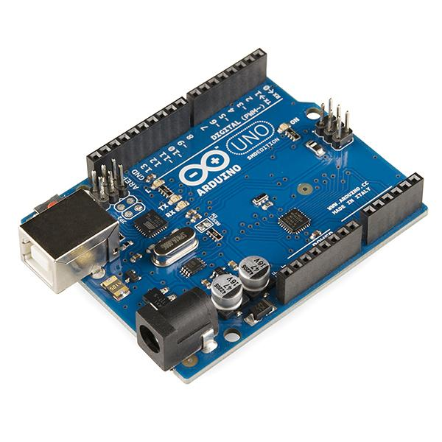

**Figure 4.1:Arduino uno**

**4.2 NodeMCU**

NodeMCU is an open-source development board built around the ESP8266 Wi-Fi module.The ESP8266 WiFi Module is a highly-integrated chip that offers a complete and self-contained WiFi networking solution, with integrated TCP/IP protocol stack. It is designed to provide an easy way to build Internet of Things (IoT) projects and prototypes by integrating Wi-Fi capabilities into the board.One of the key features of the NodeMCU board is its built-in Wi-Fi connectivity, which allows it to communicate with other devices and services over the internet. It features an integrated USB-to-serial converter, which allows it to be easily programmed using the Arduino IDE. Additionally, the NodeMCU provides a variety of GPIO pins, which can be used for interfacing with sensors, actuators, and other electronic components.This makes it ideal for projects that require remote monitoring or control, such as smart home automation or environmental monitoring.

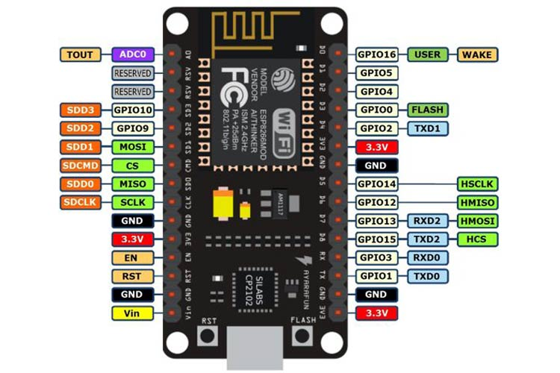

**Figure 4.2 : NodeMCU**

**4.3 DHT11 sensor**

The DHT11 sensor is a low-cost digital temperature and humidity sensor that can be used in a wide range of applications. It consists of a thermistor and a humidity sensor, both of which are connected to a single-chip digital signal output module. The sensor provides highly accurate and reliable temperature and humidity readings in a simple and easy-to-use package.The DHT11 sensor uses a capacitive humidity sensing element to measure the amount of moisture in the air. It works by measuring the capacitance of the sensing element, which changes in response to changes in humidity. This capacitance is then converted into a digital signal, which can be read by a microcontroller or other device.In addition to measuring humidity, the DHT11 sensor also includes a thermistor, which is used to measure temperature. The thermistor works by changing its resistance in response to changes in temperature, which is then converted into a digital signal that can be read by the microcontroller or other device.

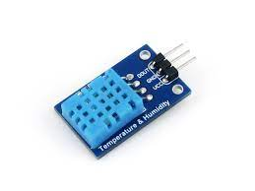

**Figure 4.3: DHT11**

**4.4 Ultrasonic sensor**

The HC SR04 Ultrasonic sensor is a versatile sensor that is commonly used to measure distance or sense objects in various applications. One of its applications is in determining the water level in a contained water body, such as dams or reservoirs. This sensor is powered using a regulated +5V through the Vcc and Ground pins, and consumes less than 15mA of current, which makes it easy to integrate with the system.The module consists of two eye-like projections in the front, which serves as the ultrasonic transmitter and receiver. When the sensor is triggered, it sends out ultrasonic waves that bounce off the surface of the water and return to the sensor. The time taken for the waves to travel and return to the sensor is used to calculate the distance from the sensor to the water level. This information can then be sent to the microcontroller or other device for further processing and analysis.

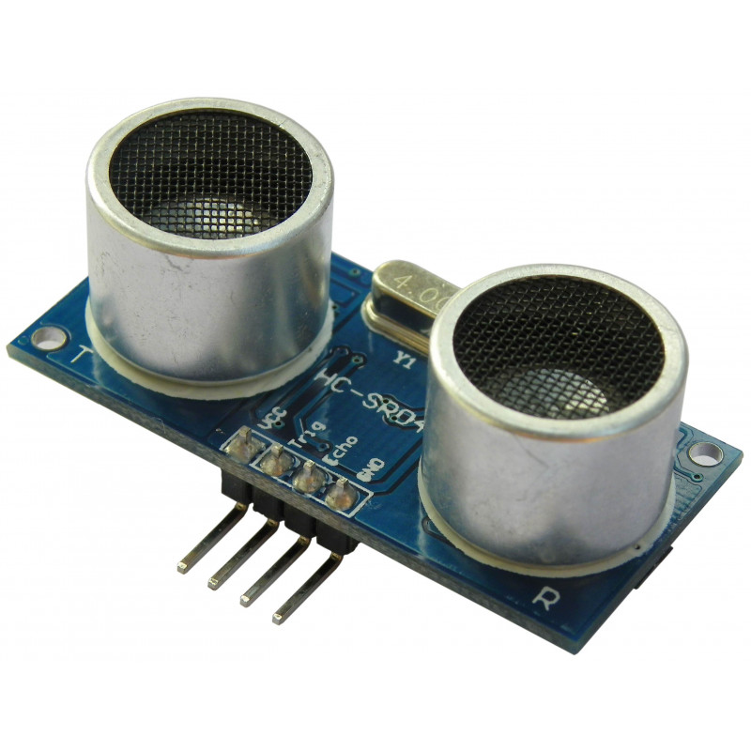

**Figure 4.4: Ultrasonic Sensor**

**4.5 WATER LEVEL SENSOR**

A water level sensor is a device that is used to measure the level of water.It works on the principle of capacitance, which is the ability of two conductive objects to store an electrical charge when placed close to each other. The sensor consists of two conductive plates placed close to each other, but not touching. When the plates are placed in water, the water acts as a dielectric medium between the plates, changing the capacitance of the sensor. The change in capacitance is then measured and converted into a water level reading.

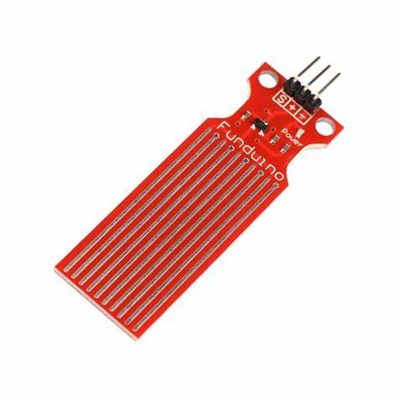

**Figure 4.5: Water Level Sensor**

**4.6 GSM Module**

GSM stands for Global System for Mobile Communications, which is a standard for digital cellular networks that use time-division multiplexing (TDM) to transmit voice and data over radio waves. A GSM module is a hardware device that enables communication with a GSM network. It contains a GSM modem, which is a type of modem that can send and receive data over a GSM network.

A GSM module typically consists of a SIM card slot, an antenna, a power supply, and a serial interface for communication with an external device, such as a microcontroller or a computer. The module communicates with the GSM network by sending and receiving AT commands, which are standard commands used to control modems.

The primary use of a GSM module is to enable remote communication between devices over a GSM network. For example, it can be used in a variety of applications, such as security systems, remote monitoring, fleet management, and home automation. In these applications, the GSM module can send and receive SMS messages or make phone calls to alert users about events or to receive instructions.

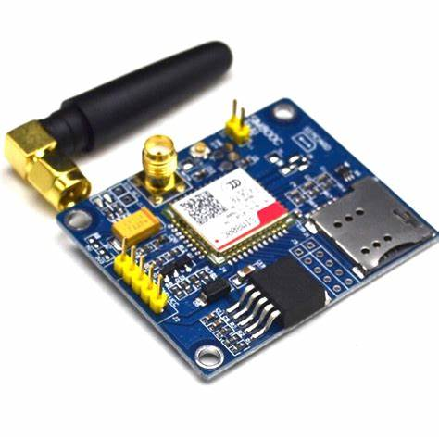

**Figure 4.6 : GSM Module**

**5. PROJECT IMPLEMENTATION**

**5.1 DESIGN**

Our project has mainly focused on designing a system that can accurately predict flood situations in riverine areas. The system comprises a transmitter section that is deployed under a bridge and a receiver section that receives data transmitted through the ESP NOW protocol. Since ESP NOW does not require WiFi, it can be used in areas where connectivity is limited. From the receiver section, the data is transmitted to a third NodeMCU, which then transfers it to the cloud and ultimately to the webpage.

Our system has the potential to be deployed at multiple points along the riverbank to provide real-time data, which can be combined to give a more accurate flood prediction. This could prove to be an essential tool for disaster management agencies to take timely and appropriate action to mitigate the effects of floods.

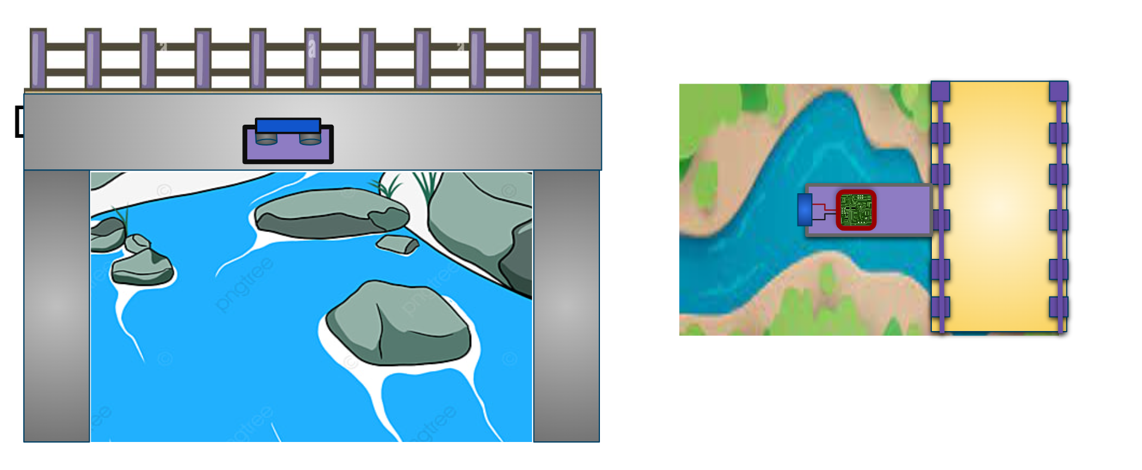

**Figure 5.1 : Device placing under the bridge**

**5.2 CIRCUIT**

The Arduino part of our model of our system was implemented in Proteus Simulation software. Proteus allowed us to simulate the behavior of the system and test its functionality without the need for physical hardware.

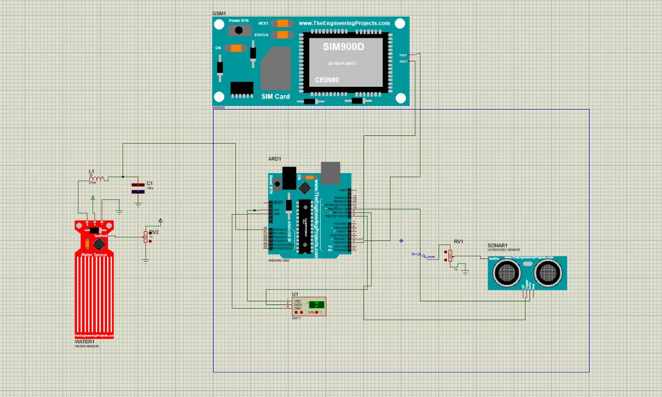

**Figure 5.2 : Circuit**

**5.3 WORKING**

The data gathered by the DHT11 sensor, water level sensor, and ultrasonic sensor is transmitted to the Arduino microcontroller for processing and analysis.The data collected by the sensors is transmitted to the first NodeMCU in the system, as well as to the GSM module from Arduino for analysis. If the readings exceed the prescribed warning levels, the GSM module will trigger an alert by sending warning messages and making calls to the concerned parties.The NodeMCU serves as a transmitter for the collected data, which is then sent to the receiver NodeMCU. From there, the data is forwarded to an ESP8266 that is equipped with Wi-Fi capability, allowing it to send the data to Thingspeak for further analysis. Our system utilizes the ESPNOW Communication protocol for data exchange between the transmitter and receiver NodeMCU, eliminating the need for Wi-Fi connectivity in areas where it may be an issue.The data transmitted to Thingspeak is analyzed and can be viewed as graphs, and can also be used for live streaming of weather updates. Our system is designed such that if the data exceeds predetermined thresholds, Thingspeak will trigger an alert message, which will be displayed in the system.The information collected from Thingspeak is displayed on a webpage that allows users to access and interpret the data. The webpage provides real-time updates on temperature, humidity and rainfall.It also displays flood alerts based on an ML prediction mechanism that we have developed[2].

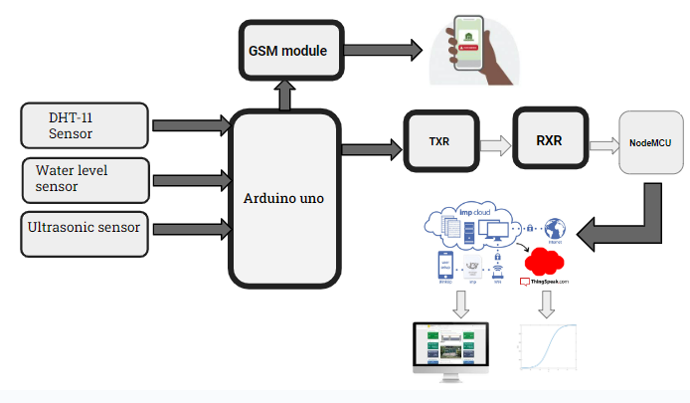

**Figure 5.3: Block Diagram of Working**

**5.4 COMMUNICATION PROTOCOL-ESP NOW**

ESP-NOW is a communication protocol developed by Espressif Systems specifically for use with their ESP8266 and ESP32 series of WiFi-enabled microcontrollers. It is a simple, lightweight protocol that allows for fast and reliable wireless communication between two or more devices.One of the key advantages of ESP-NOW is its low latency and high reliability. The protocol is designed to operate in a peer-to-peer mode, meaning that devices can communicate directly with each other without the need for a centralized hub or server. This allows for faster communication times and reduces the risk of data loss or interference.

ESP-NOW uses a 1-to-N or N-to-N communication model, where one device acts as a central hub, or "controller", and the other devices act as "slaves". The controller sends messages to the slaves, which can then respond with data or send their own messages to other devices in the network[6].

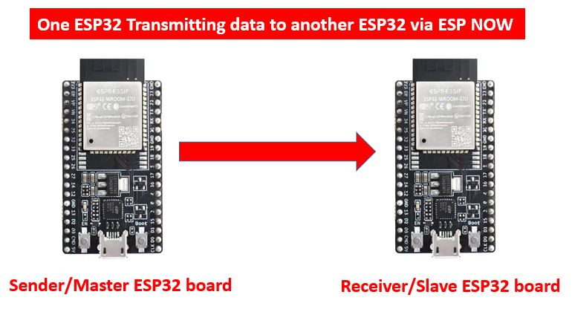

**Figure 5.4 : ESP32 Sender to Receiver board**

To use ESP-NOW, devices must first be paired using a unique 6-byte key, which is used to encrypt and decrypt data sent between devices. This key is stored in both the controller and slave devices and is used to establish a secure and reliable connection.

ESP-NOW is also highly customizable, allowing developers to specify various parameters such as the data rate, packet size, and transmission power. This makes it a versatile protocol that can be used in a wide range of applications, from simple sensor networks to more complex home automation systems.

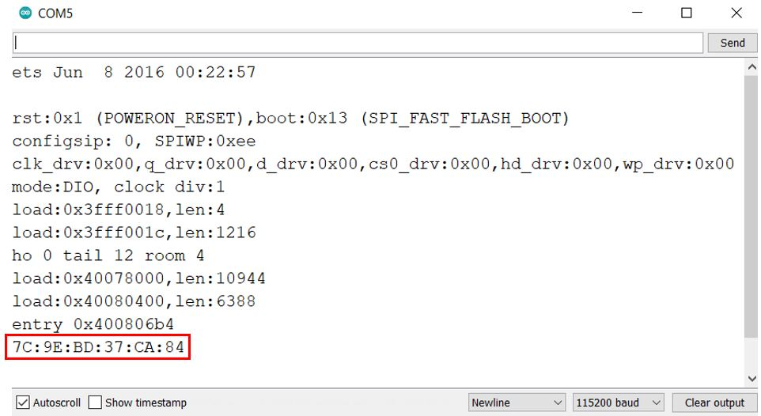

**Figure 5.5 : MAC Address**

**6.OUTPUT**

**6.1 GSM Module Alert**

The GSM (Global System for Mobile Communications) module is an important component of the flood detection and alert system. It is used to provide SMS (Short Message Service) and call alerts to notify the relevant authorities or individuals in case of an emergency or if the data from the Arduino exceeds the threshold value.

When the water level being monitored crosses a predefined threshold value, the Arduino board sends a signal to the GSM module. The GSM module then sends an SMS alert to the designated phone numbers and/or makes a call to the specified phone numbers.This feature ensures that the appropriate authorities and individuals are notified in real-time if there is a potential risk of flooding or if the water level is too high.

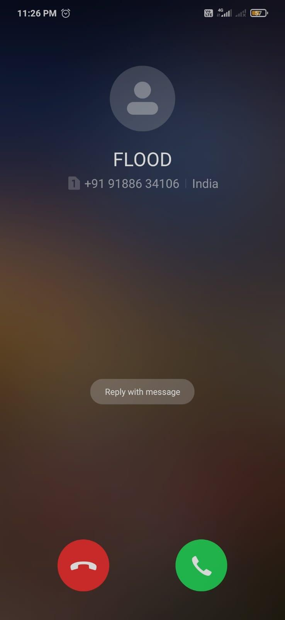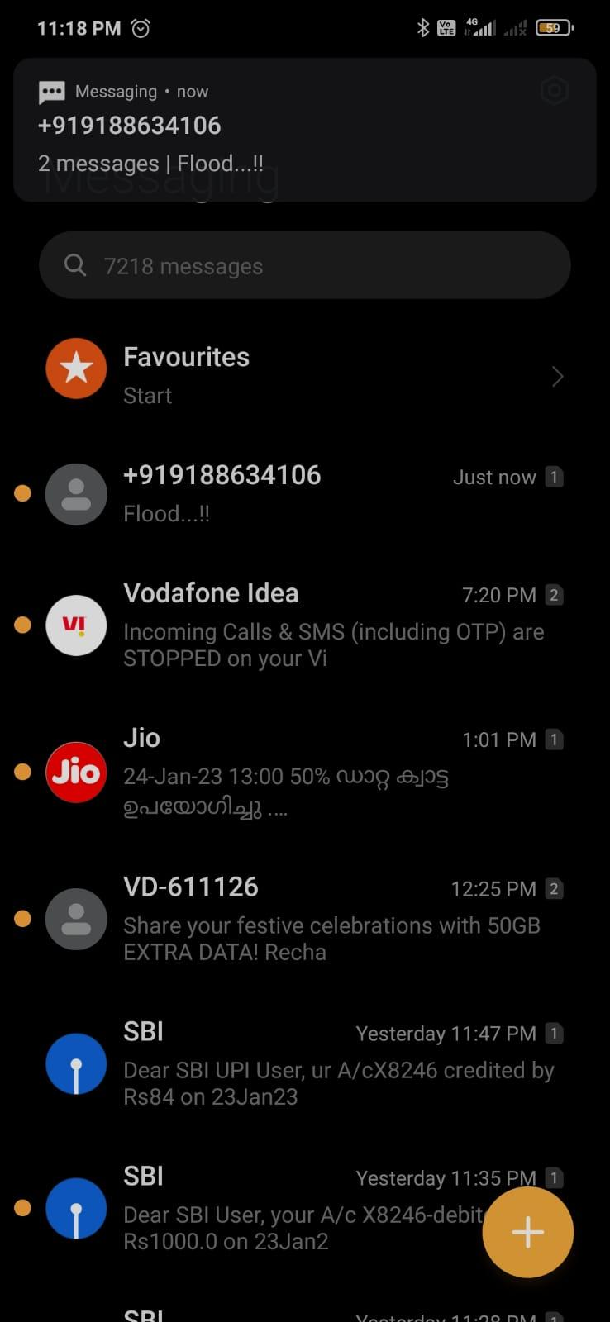

**Figure 6.1:** **Alert Through Gsm**

**6.2 Thingspeak Data Visualization**

In the ThingSpeak platform, our flood detection and alert system project utilizes four distinct labels to display the collected data in a more organized and easily understandable manner. These labels include temperature, humidity, distance, and water level. The temperature label displays the temperature of the surrounding environment, the humidity label displays the moisture content in the air, the distance label displays the distance of the water level from the ultrasonic sensor, and the water level label displays the current water level .

Furthermore, our system also includes an alert feature that provides timely notifications when the water level exceeds a predefined threshold. This threshold can be set according to the specific requirements of the user, ensuring that they are notified when the water level reaches a critical point.

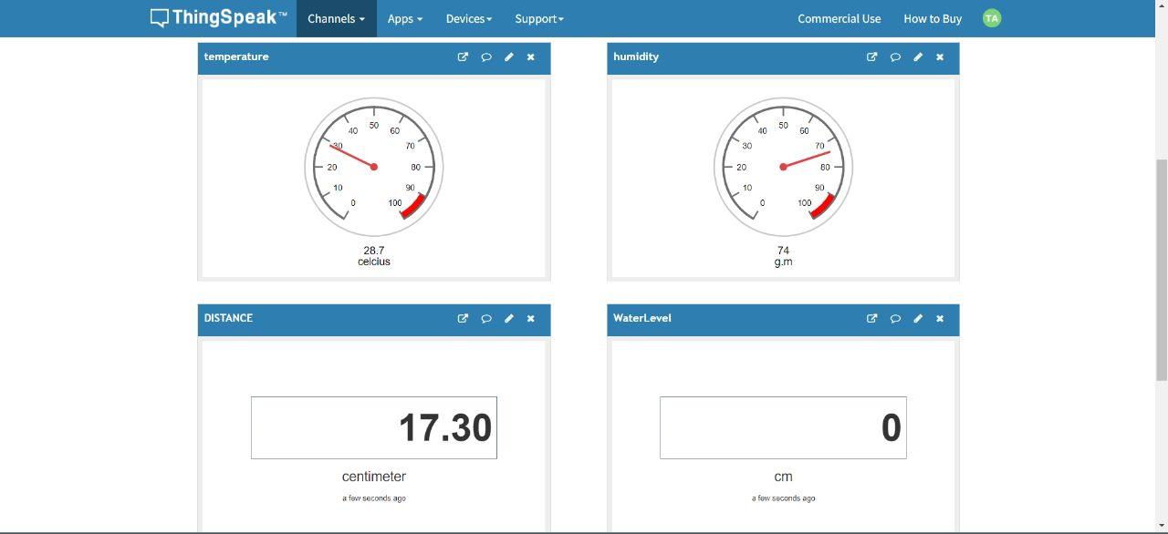

**Figure 6.2 :Thingspeak data Visualization**

**6.3 Webpage**

The webpage serves as a user-friendly interface for displaying and monitoring the sensor data.The sensor details such as temperature, humidity, distance, and water level are obtained from the data received in ThingSpeak. The sensor data is collected from the ThingSpeak IoT cloud using its API and converted to a CSV file format using Python code. These CSV files are then transferred to different Google Sheets for each data generated in different time intervals. Finally, the data from Google Sheets is fetched and displayed on a locally hosted web page, which showcases details such as temperature, humidity, rainfall amount, and water level.

.The web page is integrated with a machine learning model trained to predict the possibility of floods based on the current weather and water level data. If the model predicts the likelihood of flooding, the website generates an alert message to notify the user of potential danger. This allows for early warning and preparation, potentially saving lives and minimizing property damage.

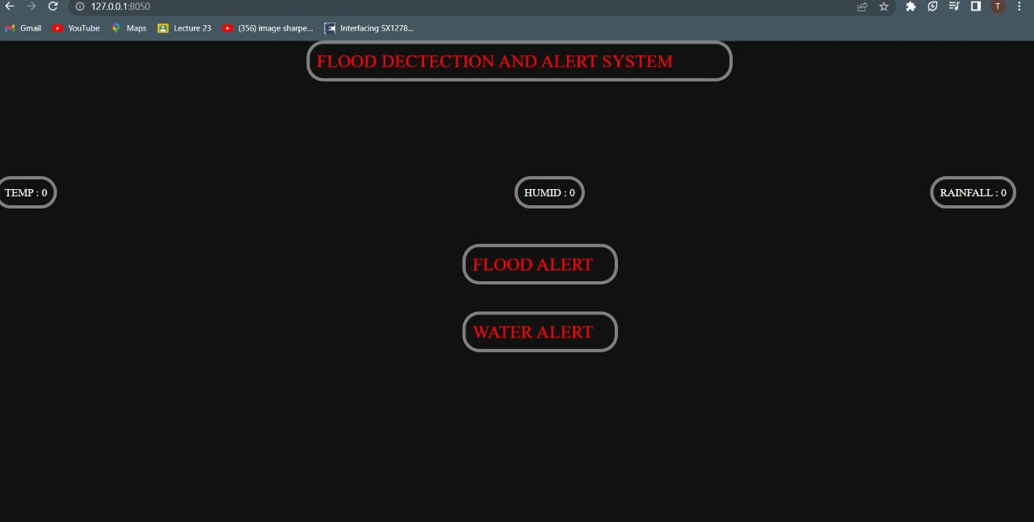

**Figure 6.3 : Web page Output**

**6.4 MACHINE LEARNING**

Machine learning is a subfield of artificial intelligence that involves training computer algorithms to automatically improve with experience. The algorithms are trained on large datasets, which enables them to identify patterns and relationships within the data, and use that information to make predictions or decisions about new data.Machine learning has a wide range of applications, from image and speech recognition to predicting customer behavior and optimizing business processes. It is also used in fields such as healthcare, finance, and transportation to analyze large amounts of data and make more accurate predictions or decisions[2]

For our project, we used a regression model using machine learning techniques to predict the likelihood of a flooding using weather data from Kerala during the 2018 floods. The data used in this study was collected from February to December 2018. The model was built using popular Python libraries, including TensorFlow, NumPy, and Pandas. The architecture of the model consisted of three dense layers, with 12, 8, and 1 nodes respectively, and a sigmoid activation function for binary classification. The model was optimized using the ADAM optimizer algorithm and trained for 150 epochs, with a batch size of 10, to achieve maximum accuracy[5]

We achieved an accuracy of 93.09%.The model's accuracy is expected to increase with a larger dataset, given that the current accuracy was based on one year of weather data, spanning from February to December 2018.

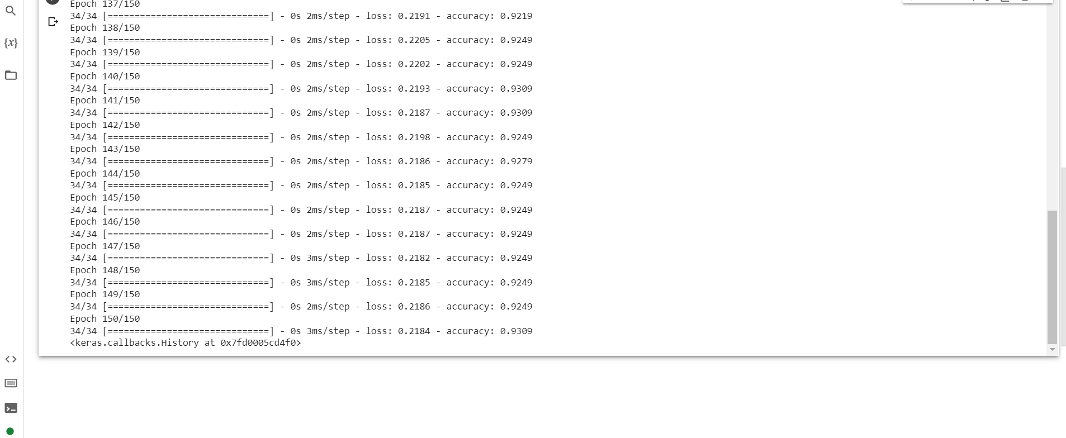

**Figure 6.4 : FINAL PREDICTION ACCURACY : 93.09%**

**7. FUTURE SCOPE**

The future scope of our project is vast, and there are several ways in which it can be improved and expanded. One of the key areas for improvement is the accuracy of the flood prediction model. While our model has achieved a high accuracy rate of 93.09% based on one year's data, there is room for further improvement. To achieve this, we can collect more data over a longer period of time and incorporate more features into the model.Adding more sensors to measure factors such as wind speed and direction, barometric pressure, and soil moisture levels can provide a more comprehensive picture of the weather conditions and help in predicting floods more accurately.Integrating the system with emergency services such as local government bodies, hospitals, and relief centers can help in better disaster management and preparedness.A mobile app can be developed to provide users with up-to-date information on weather conditions and flood risks. It can also be used to alert users in real-time if there is a possibility of flooding.Overall, our project has the potential to make a significant impact in addressing the challenge of flooding in vulnerable regions. By continuing to refine and expand the system, we can contribute to a safer and more sustainable future for communities at risk of flooding.

**8.CONCLUSION**

In conclusion, our project aimed to provide a solution for flood detection and alerting using IoT technology and machine learning. By implementing a system that integrates sensors, microcontrollers, cloud platforms, and ML models, we were able to achieve accurate predictions and timely notifications to help prevent flood-related disasters.

Through our experiments and testing, we demonstrated that our system can effectively collect and process real-time data on temperature, humidity, water level, and distance. We also showed that our regression model can accurately predict the occurrence of floods based on historical weather data.Our project has several potential applications in the field of disaster management and mitigation. By incorporating more advanced sensors and ML algorithms, we can further improve the accuracy and reliability of our system. Additionally, we can expand our project to cover a larger geographic area and incorporate more stakeholders such as local governments and emergency response teams.Overall, our project serves as a proof-of-concept for the use of IoT and ML in flood detection and management.

**9.REFERENCES**

[1].A. Pravin, T. P. Jacob and R. Rajakumar, "Enhanced Flood Detection System using IoT," 2021 6th International Conference on Communication and Electronics Systems (ICCES), Coimbatore, India, 2021, pp. 507-510, doi: 10.1109/ICCES51350.2021.9489059.

[2].A. A. Rashid, M. A. M. Ariffin and Z. Kasiran, "IoT-Based Flash Flood Detection and Alert Using TensorFlow," 2021 11th IEEE International Conference on Control System, Computing and Engineering (ICCSCE), Penang, Malaysia, 2021, pp. 80-85, doi: 10.1109/ICCSCE52189.2021.9530926.

[3]. E. Basha and D. Rus, “Design of early warning flood detection systems for developing countries,” 2007 International Conference on Information and Communication Technologies and Development, Bangalore, 2007

[4].Ragnoli, M.; Barile, G.; Leoni, A.; Ferri, G.; Stornelli, V. An Autonomous Low-Power LoRa-Based Flood-Monitoring System. J. Low Power Electron. Appl. 2020, 10, 15. <https://doi.org/10.3390/jlpea10020015>

[5].K. Lohumi and S. Roy, "Automatic Detection of Flood Severity Level from Flood Videos using Deep Learning Models," 2018 5th International Conference on Information and Communication Technologies for Disaster Management (ICT-DM), Sendai, Japan, 2018, pp. 1-7, doi: 10.1109/ICT-DM.2018.8636373.

[6]. N. Hoang, S. -T. Van and B. D. Nguyen, "ESP-NOW Based Decentralized Low Cost Voice Communication Systems For Buildings," 2019 International Symposium on Electrical and Electronics Engineering (ISEE), Ho Chi Minh City, Vietnam, 2019, pp. 108-112, doi: 10.1109/ISEE2.2019.8921062.